**Regression Algorithms**

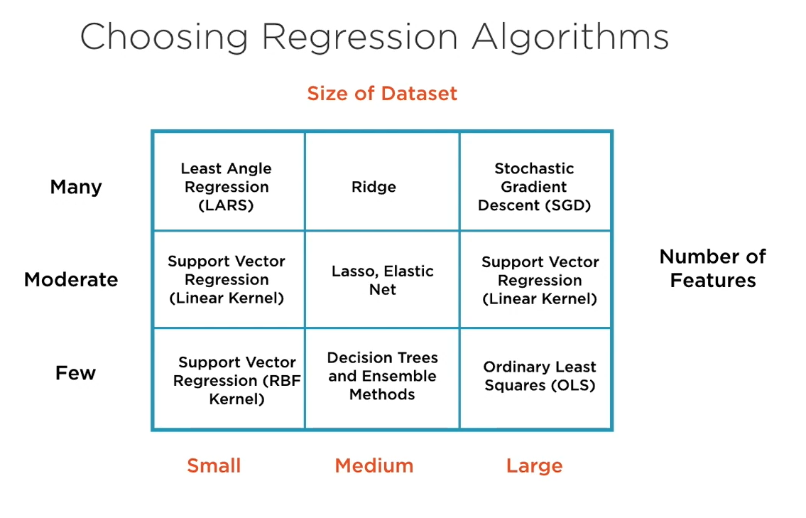

**Evaluating Regression Models:**

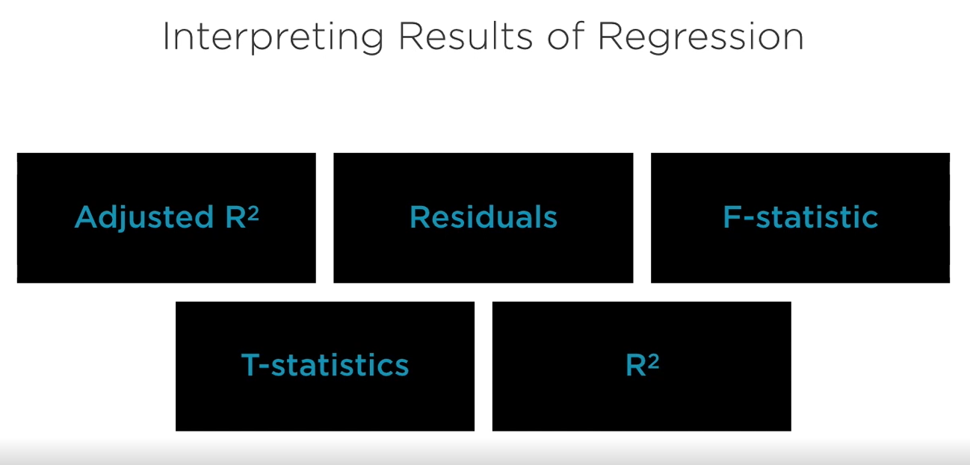

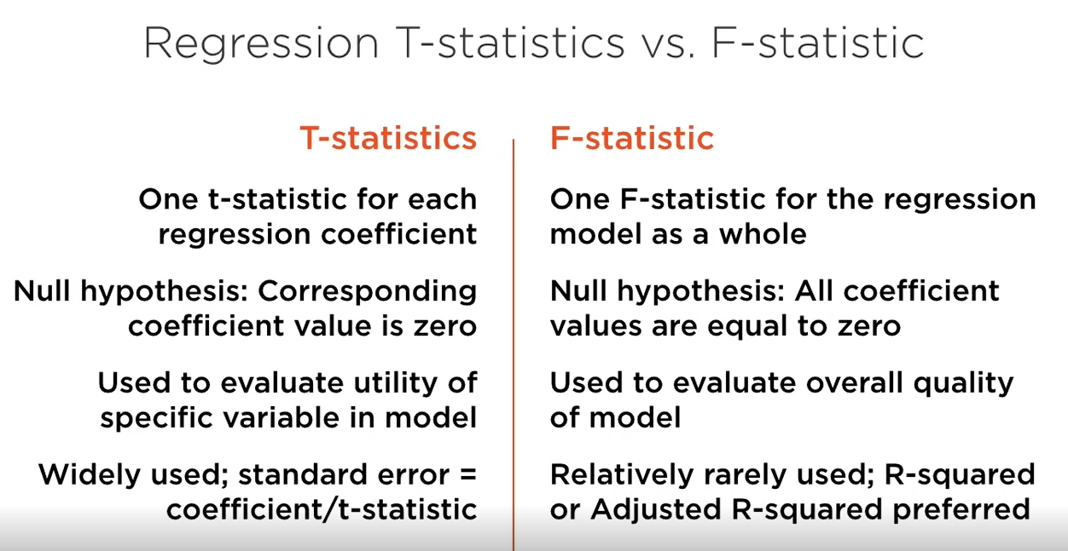

**Classification Algorithms**

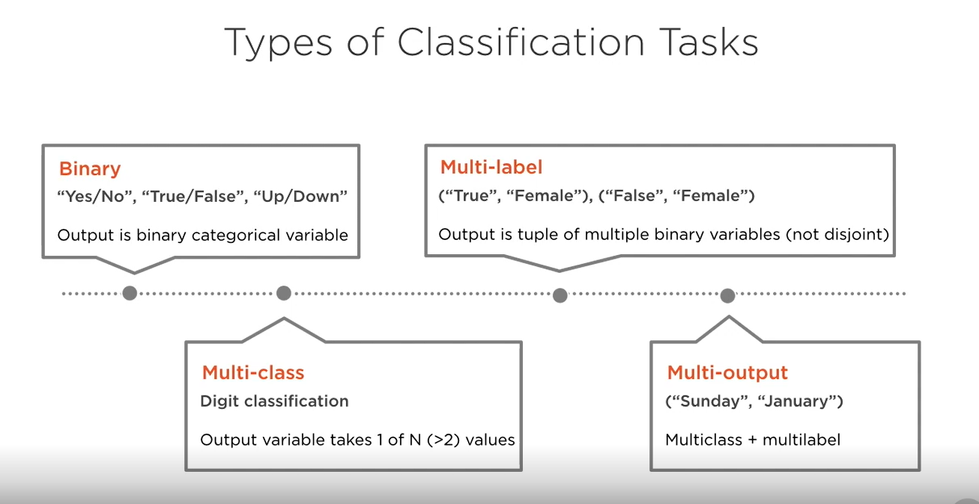

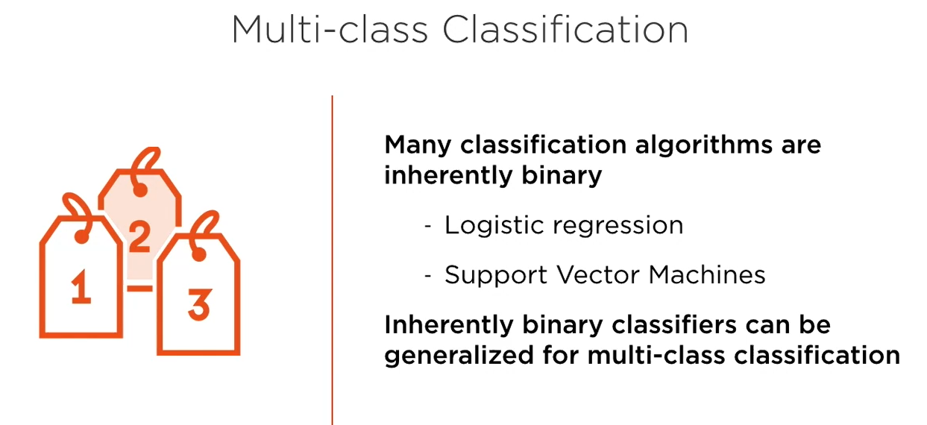

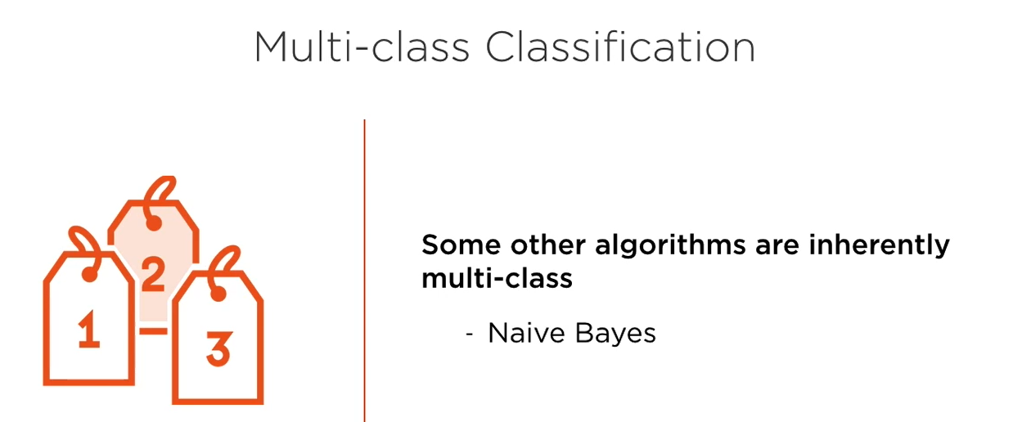

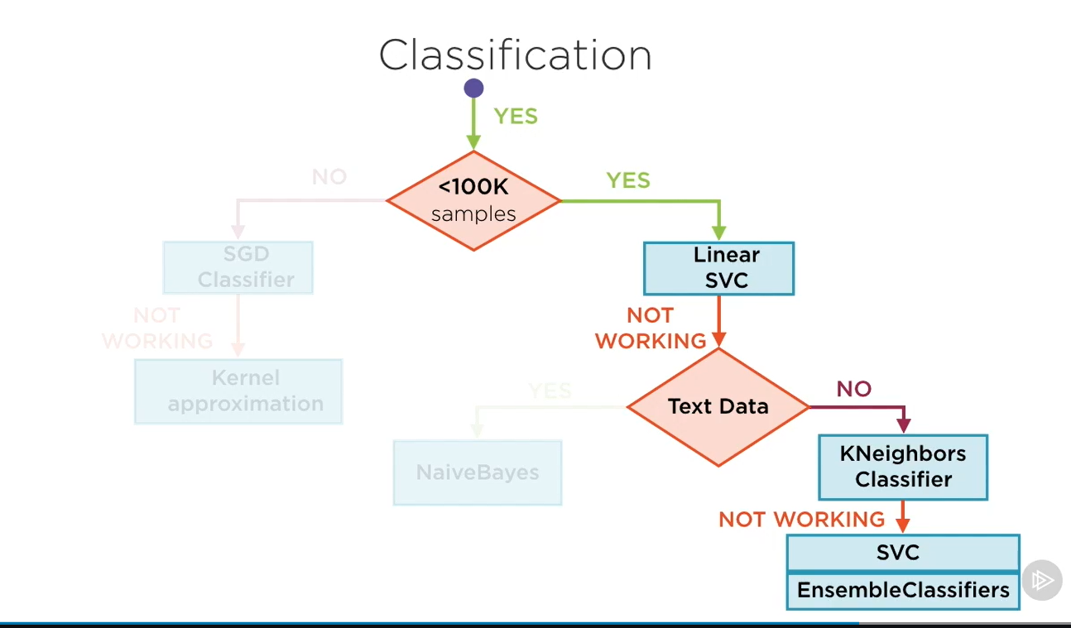

**Evaluating Classification Models:**

**Accuracy is not a great metric to evaluate Classification models.**

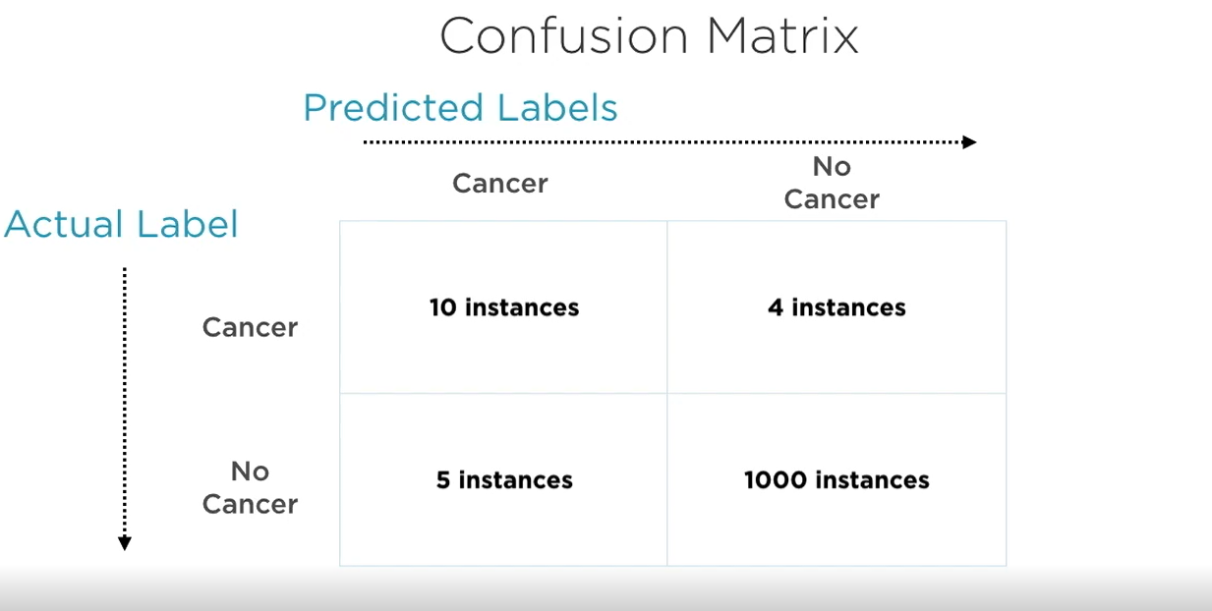

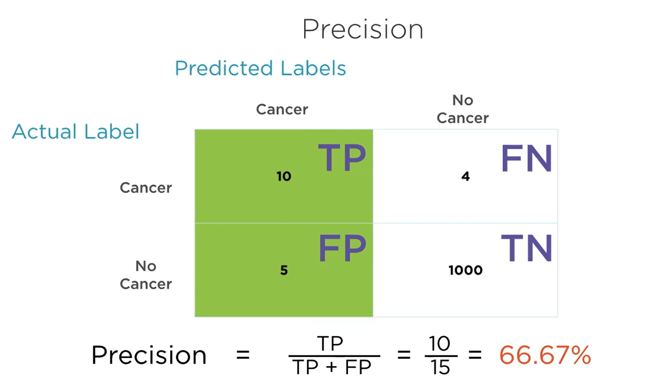

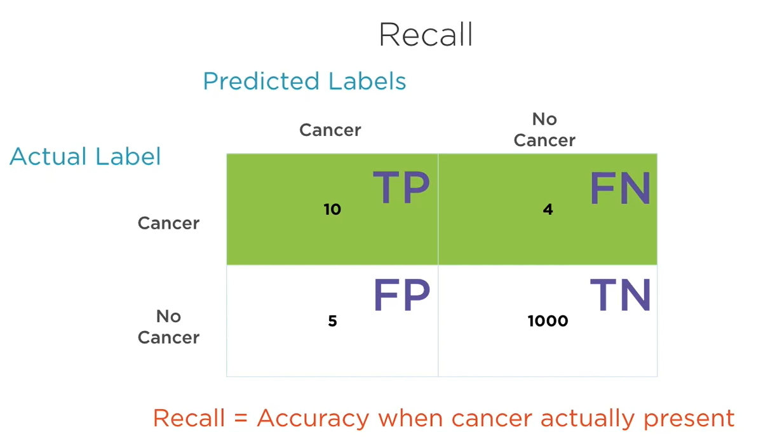

**Clustering Algorithms**

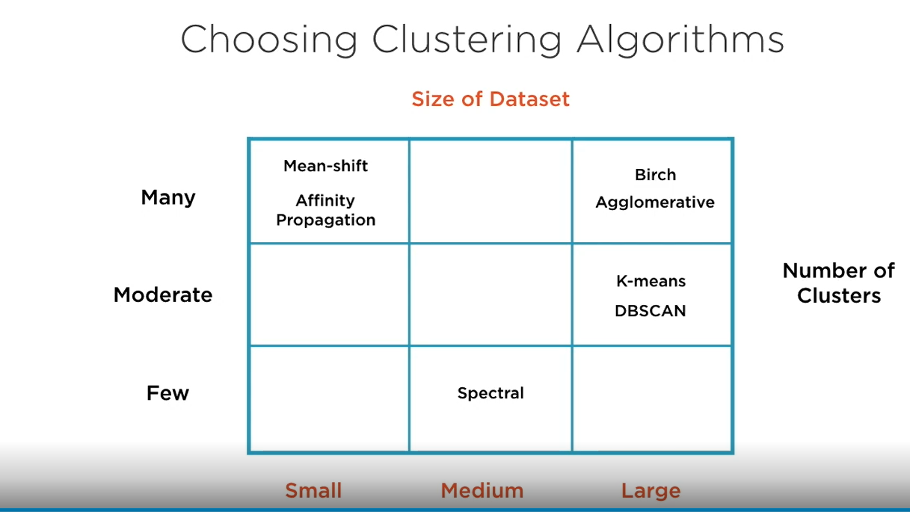

**The curse Dimensionality**

As number of x variables grows, several problems arise in visualization, training and prediction.

**Problems in visualization:**

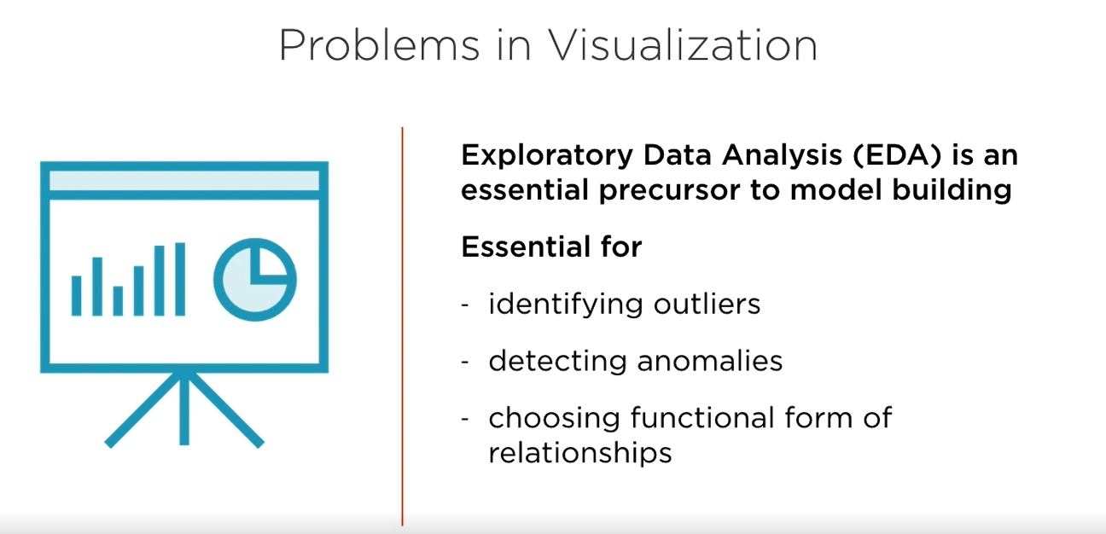

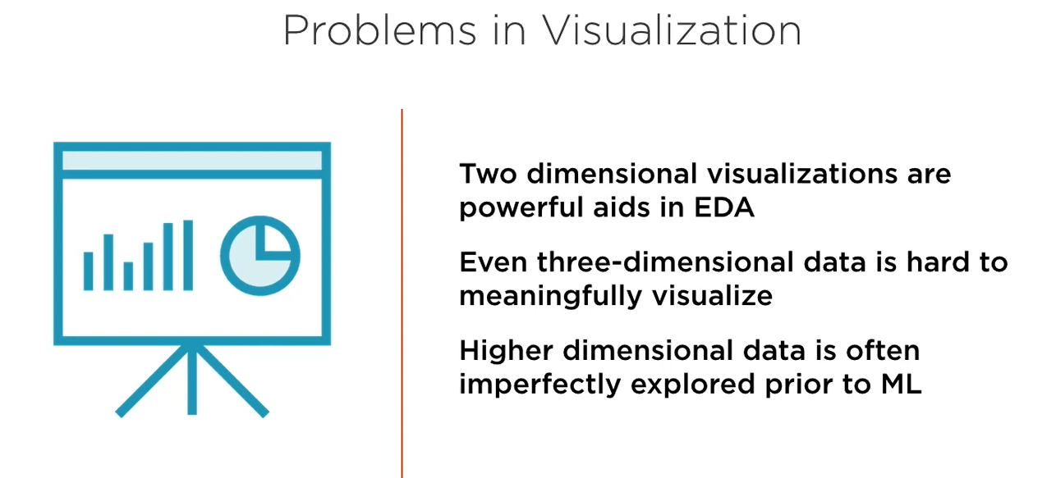

**Problems in Training**

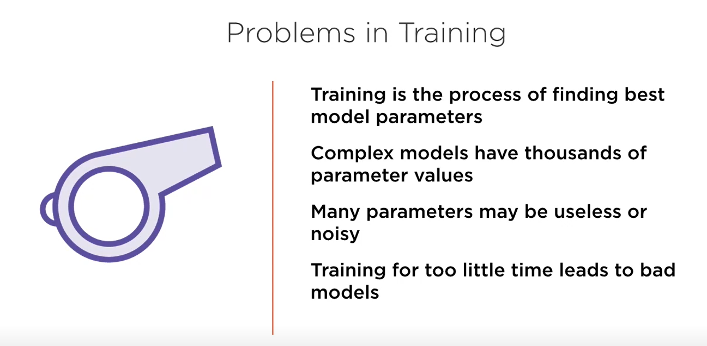

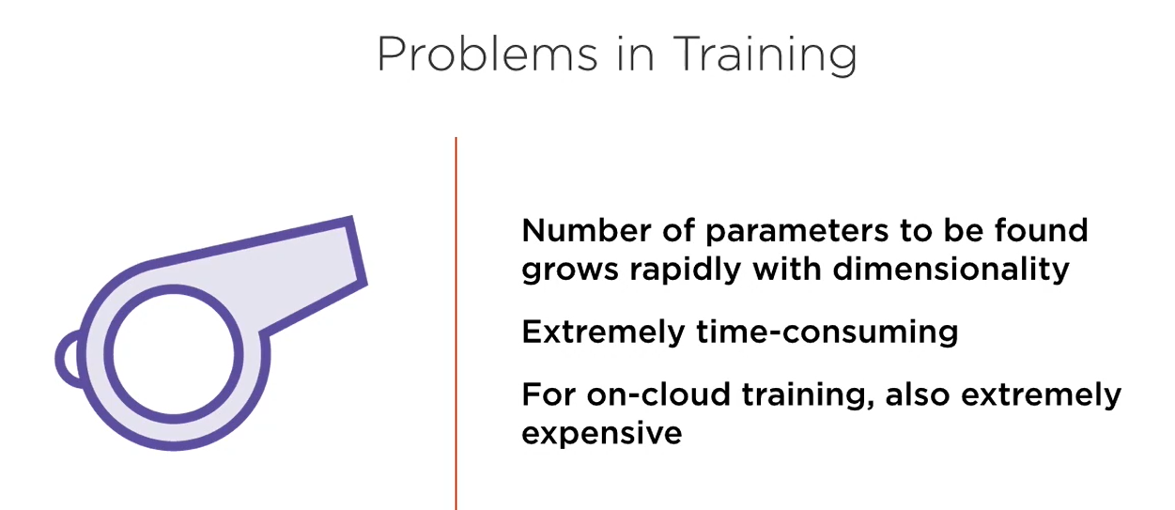

**Problems in Prediction:**

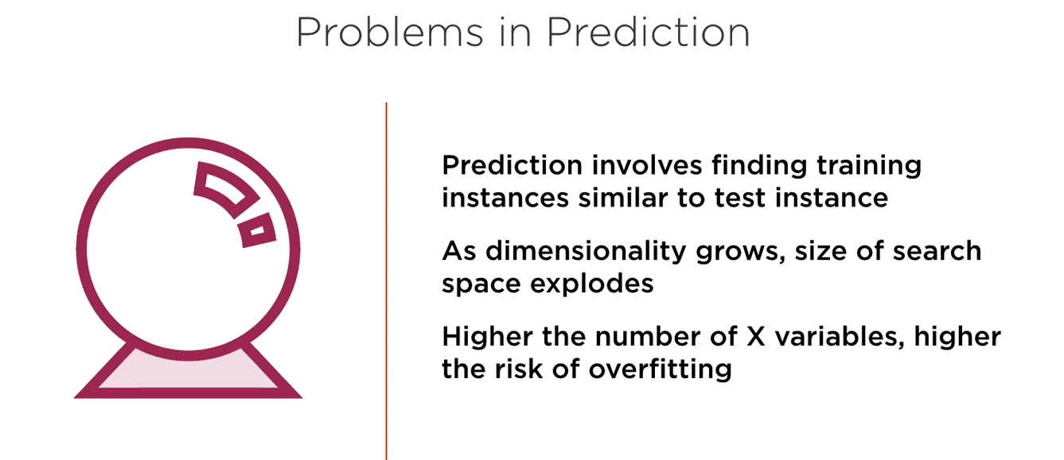

**Reduction Complexity**

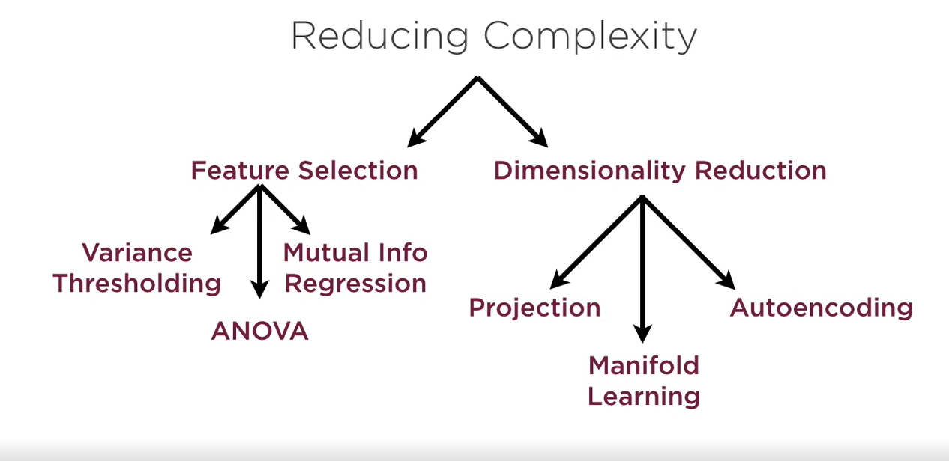

Feature Selection: Choose a subset of original X variables

Dimensionality Reduction: Transform original X variables into new dimensions

**Projection**: Find new, better axes and re-orient data: example: PCA ( principle component analysis), Factor Analysis, LDA( Linear Discrimination Analysis) and QDA ( Quadrant Discrimination analysis).

Works best with linear data and can use kernel trick to extend non-linear data.

**Manifold learning**: Unroll the data so that twists and turns are smoothened out. Works best when data lies a rolled-up surface such as a Swiss Roll or S-curve. Example: MDS, Isomap, LLE, Kernel PCA

**Auto encoding**: If working with high dimensionality data such as images or videos, we choose auto encoding to find the best features in the data. We build neural networks to simplify the data.